Riding Wild

A woman, her dog, and three wild horses are planning on journeying 4,000 miles to help protect the greatest remaining wilderness in North America: The Sacred Headwaters.

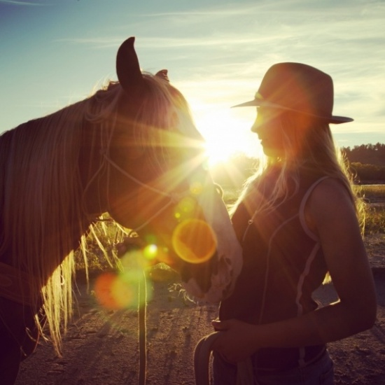

02:40
06:03

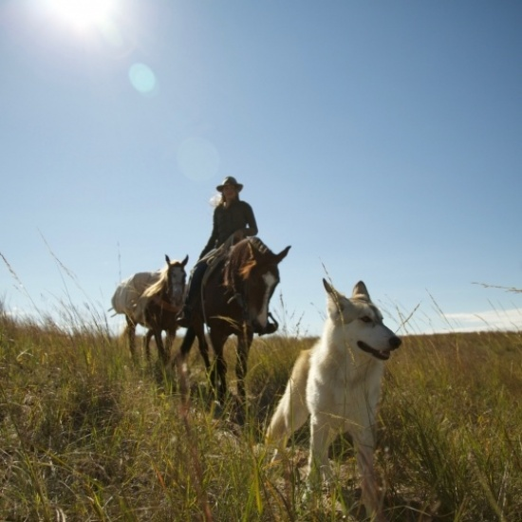

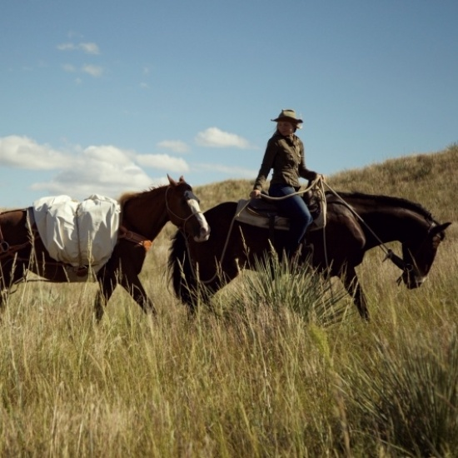

Riding Wild is an adventure and documentary film project by Aniela Gottwald with the goal of riding 4,000 miles from the U.S. - Mexican Border to the Sacred Headwaters of Canada. With this ride Aniela hopes to bring awareness to the tsunami of coal mining development destined for North Western British Columbia and inspire a movement to explore and protect the remote frontiers of the natural world that support our life on the planet.
This story has a unique and pivotal timeliness. More than ever before we have a responsibility as human beings to move toward a path of sustainability and away from a path that threatens our global survival. Our wild horses face a dire situation, as the Bureau of Land Management recently voted for the euthenization of 45,000 horses. There is a common thread between First Nations Rights, their traditional rights to their land and resources that have not been respected or supported by the governmental system. Our greatest goal is to raise awareness and in turn enough support to help the Tahltan and Gitxsan First Nations legally protect the Sacred Headwaters from mining development. This ride will give me the leverage to bring attention to finding solutions for wild horses and advocating for the protection of our natural world from inappropriate industrial development.

To donate: https://www.crowdrise.com/riding-wild/fundraiser/anielagottwald

